**Advanced Programming 2**

**Assignment 6**

1. **108.Convert Sorted Array to Binary Search Tree**

**Code:**

/**

 * Definition for a binary tree node.

 * struct TreeNode {

 *     int val;

 *     TreeNode *left;

 *     TreeNode *right;

 *     TreeNode() : val(0), left(nullptr), right(nullptr) {}

 *     TreeNode(int x) : val(x), left(nullptr), right(nullptr) {}

 *     TreeNode(int x, TreeNode *left, TreeNode *right) : val(x), left(left), right(right) {}

 * };

 */

class Solution {

public:

    TreeNode* sortedArrayToBST(vector<int>& nums) {

        return Tree (nums,0,nums.size()-1);

    }

private:

    TreeNode* Tree(vector<int>& nums, int left,int right){

        if(left>right)  return nullptr;

        int mid=left+(right-left)/2;

        TreeNode* root = new TreeNode(nums[mid]);

        root->left = Tree(nums,left,mid-1);

        root->right = Tree(nums,mid+1,right);

        return root;

    }

};

**Output:**

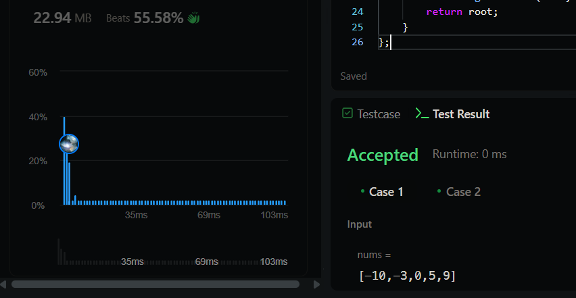

1. **191.Number of 1 Bits**

**Code:**

class Solution {

public:

    int hammingWeight(int n) {

      int count = 0;

        for(int i = 31; i >= 0; i--){

            if(((n >> i) & 1) == 1)

                count++;

        }

        return count;

    }

};

**Output:**

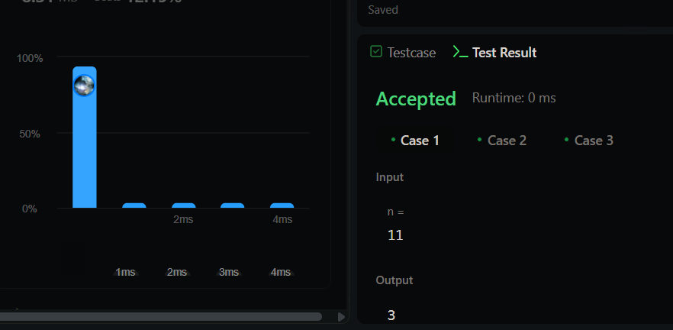

1. **912.Sort an Array**

**Code:**

class Solution {

public:

vector<int> sortArray(vector<int>& nums) {

mergeSort(nums, 0, nums.size() - 1);

return nums;

}

private:

void mergeSort(vector<int>& nums, int left, int right) {

if (left >= right) return;

int mid = left + (right - left) / 2;

mergeSort(nums, left, mid);

mergeSort(nums, mid + 1, right);

merge(nums, left, mid, right);

}

void merge(vector<int>& nums, int left, int mid, int right) {

vector<int> temp;

int i = left, j = mid + 1;

while (i <= mid && j <= right) {

if (nums[i] <= nums[j]) temp.push_back(nums[i++]);

else temp.push_back(nums[j++]);

}

while (i <= mid) temp.push_back(nums[i++]);

while (j <= right) temp.push_back(nums[j++]);

for (int k = 0; k < temp.size(); k++) {

nums[left + k] = temp[k];

}

}

};

**Output:**



1. **53.Maximum Subarray**

**Code:**

class Solution {

public:

    int maxSubArray(vector<int>& nums) {

        int res = nums[0];

        int total = 0;

        for (int n : nums) {

            if (total < 0) {

                total = 0;

            }

            total += n;

            res = max(res, total);

        }

        return res;

    }

};

**Output:**

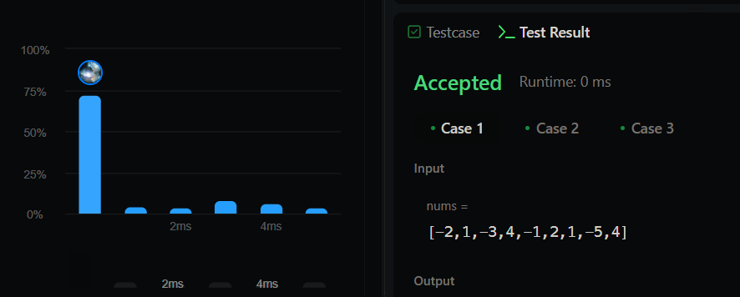

1. **932.Beautiful Array**

**Code:**

class Solution {

public:

    vector<int> beautifulArray(int n) {

        if(n==1)

            return {1};

        vector<int> even = beautifulArray(n/2);

        vector<int> odd = beautifulArray(n-(n/2));

        vector<int>ans;

        for(auto e:even)

            ans.push_back(2*e);

        for(auto e:odd)

            ans.push_back((2*e)-1);

        return ans;

    }

};

**Output:**



1. **372.Super Pow**

**Code:**

class Solution {

    const int base = 1337;

    int powmod(int a, int k)

    {

        a %= base;

        int result = 1;

        for (int i = 0; i < k; ++i)

            result = (result * a) % base;

        return result;

    }

public:

    int superPow(int a, vector<int>& b) {

        if (b.empty()) return 1;

        int last_digit = b.back();

        b.pop_back();

        return powmod(superPow(a, b), 10) * powmod(a, last_digit) % base;

    }

};

**Output:**

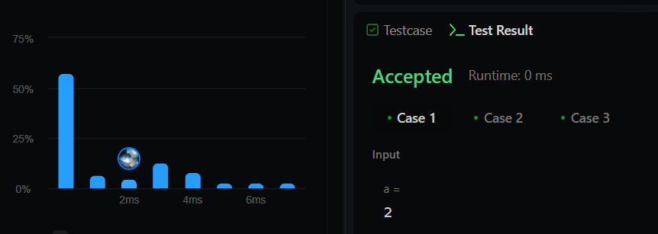

1. **218.The Skyline Problem**

**Code:**

class Solution {

public:

    vector<vector<int>> getSkyline(vector<vector<int>>& buildings) {

        int edge_idx = 0;

        vector<pair<int, int>> edges;

        priority_queue<pair<int, int>> pq;

        vector<vector<int>> skyline;

        for (int i = 0; i < buildings.size(); ++i) {

            const auto &b = buildings[i];

            edges.emplace_back(b[0], i);

            edges.emplace_back(b[1], i);

        }

        sort(edges.begin(), edges.end());

        while (edge_idx < edges.size()) {

            int curr_height;

            const auto &[curr_x, _] = edges[edge_idx];

            while (edge_idx < edges.size() &&

                    curr_x == edges[edge_idx].first) {

                const auto &[_, building_idx] = edges[edge_idx];

                const auto &b = buildings[building_idx];

                if (b[0] == curr_x)

                    pq.emplace(b[2], b[1]);

                ++edge_idx;

            }

            while (!pq.empty() && pq.top().second <= curr_x)

                pq.pop();

            curr_height = pq.empty() ? 0 : pq.top().first;

            if (skyline.empty() || skyline.back()[1] != curr_height)

                skyline.push_back({curr_x, curr_height});

        }

        return skyline;

    }

};

**Output:**

